Table of Contents

Initial condition: 2

Main.java Breakpoints 2

Line 18 2

Network.java Breakpoints 2

Line 182, 189, 197, 207 5

Line 221, 233 5

Drone.java Breakpoints 6

Line 17 6

Main.java Breakpoint Debugger Info 8

Network.java Breakpoint Debugger Info 8

Fixing Issue 9

New Run 10

# Initial condition:

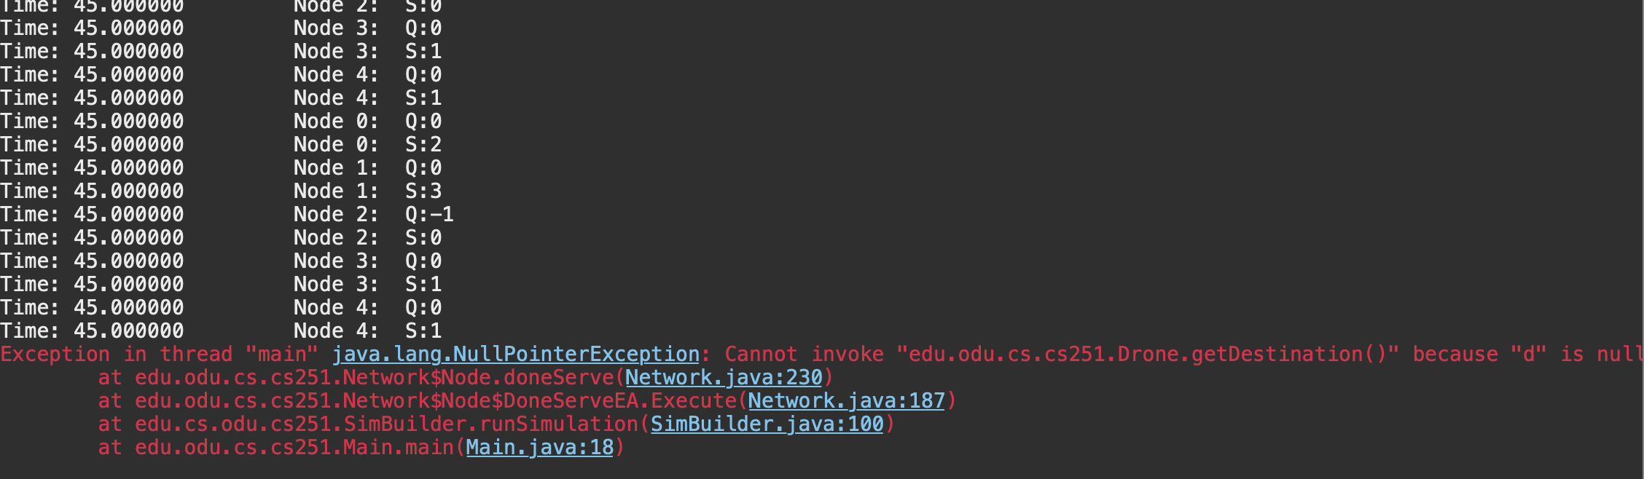

# Main.java Breakpoints

## Line 18

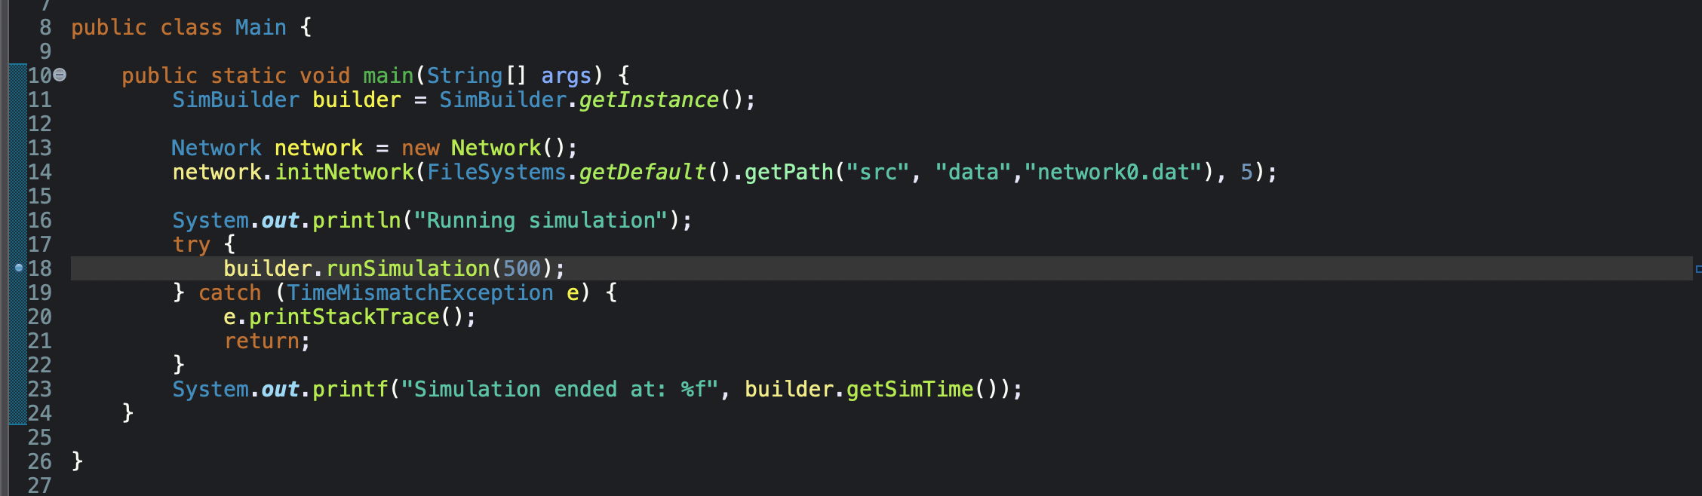

# Network.java Breakpoints

Settings:

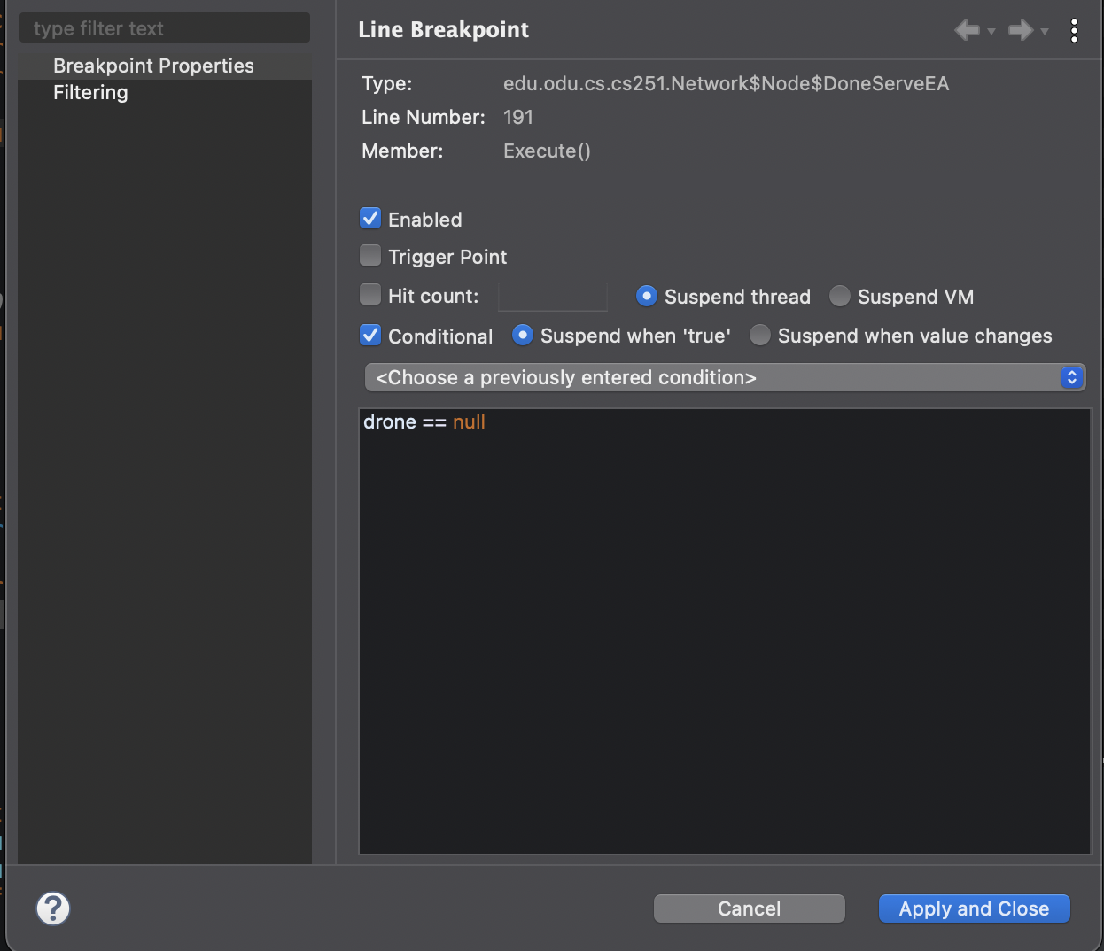

Stops if the drone is null

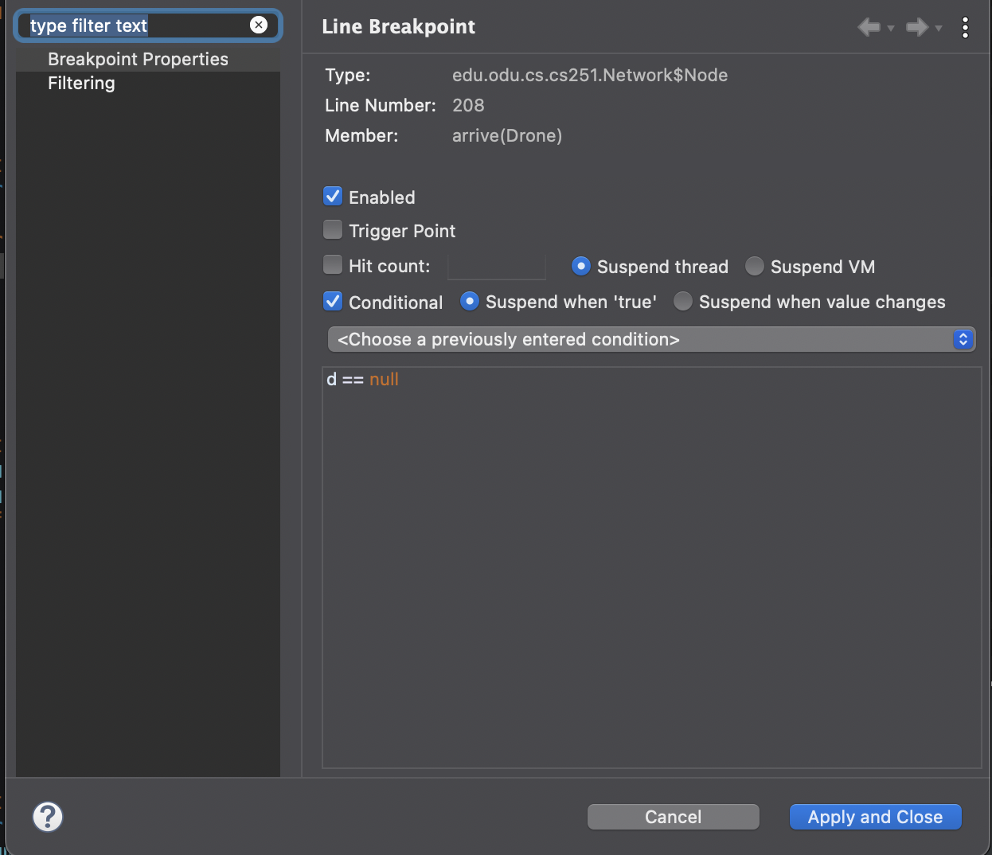

Did the same thing for the rest of the breakpoints in the file

## Line 182, 189, 197, 207

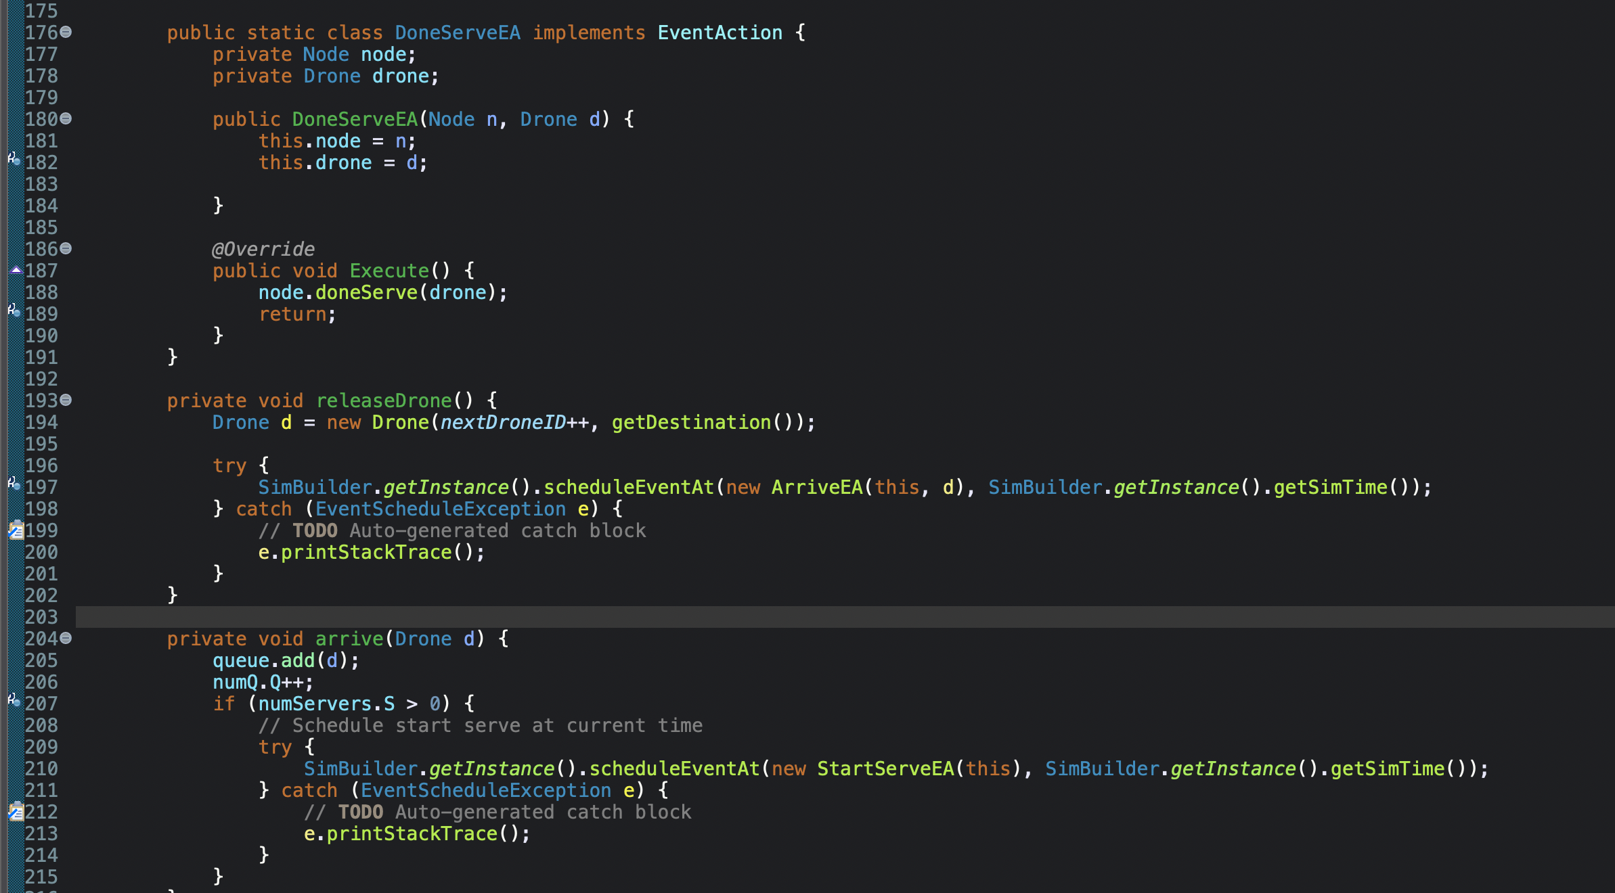

## Line 221, 233

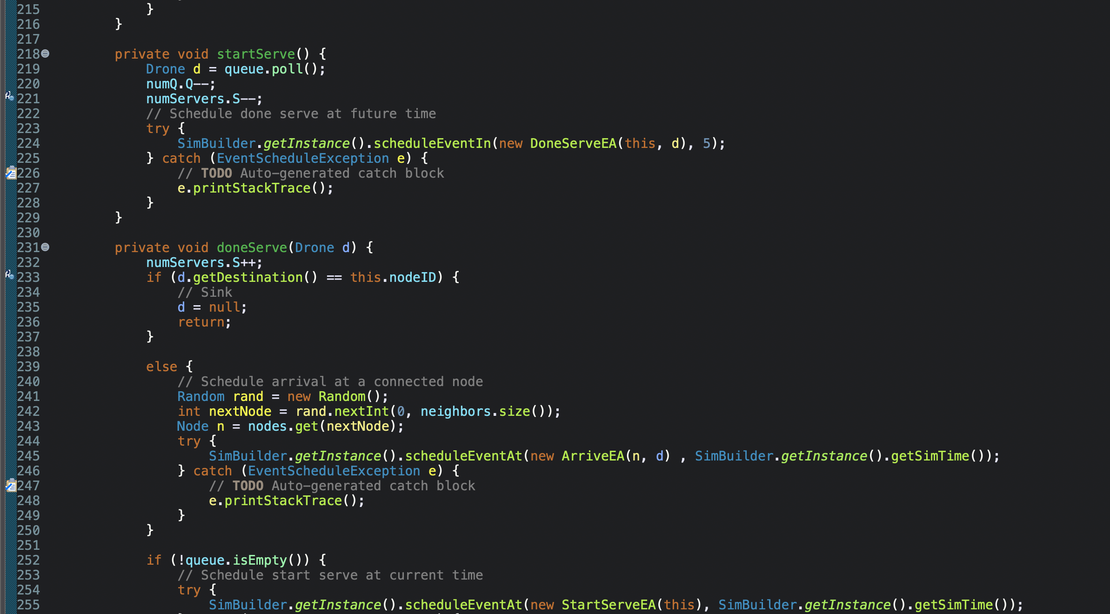

# Drone.java Breakpoints

## Line 17

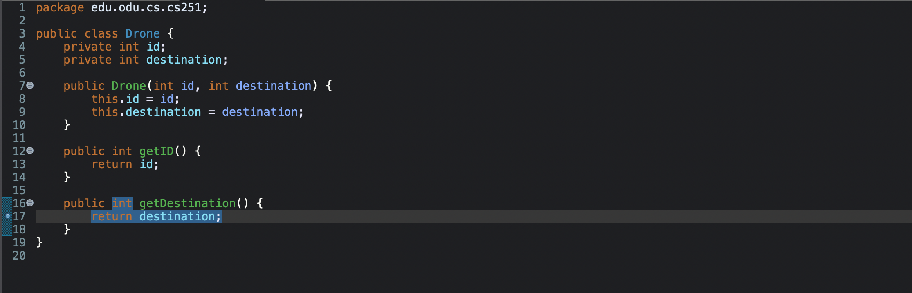

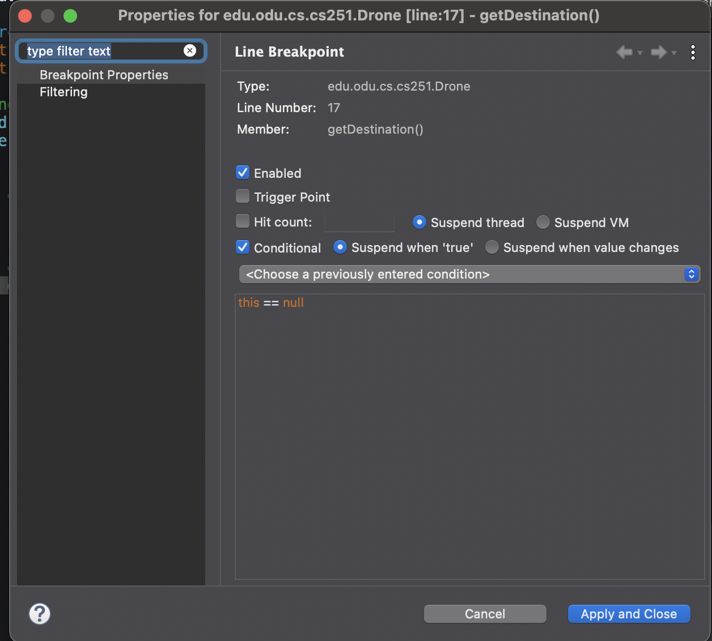

# Main.java Breakpoint Debugger Info

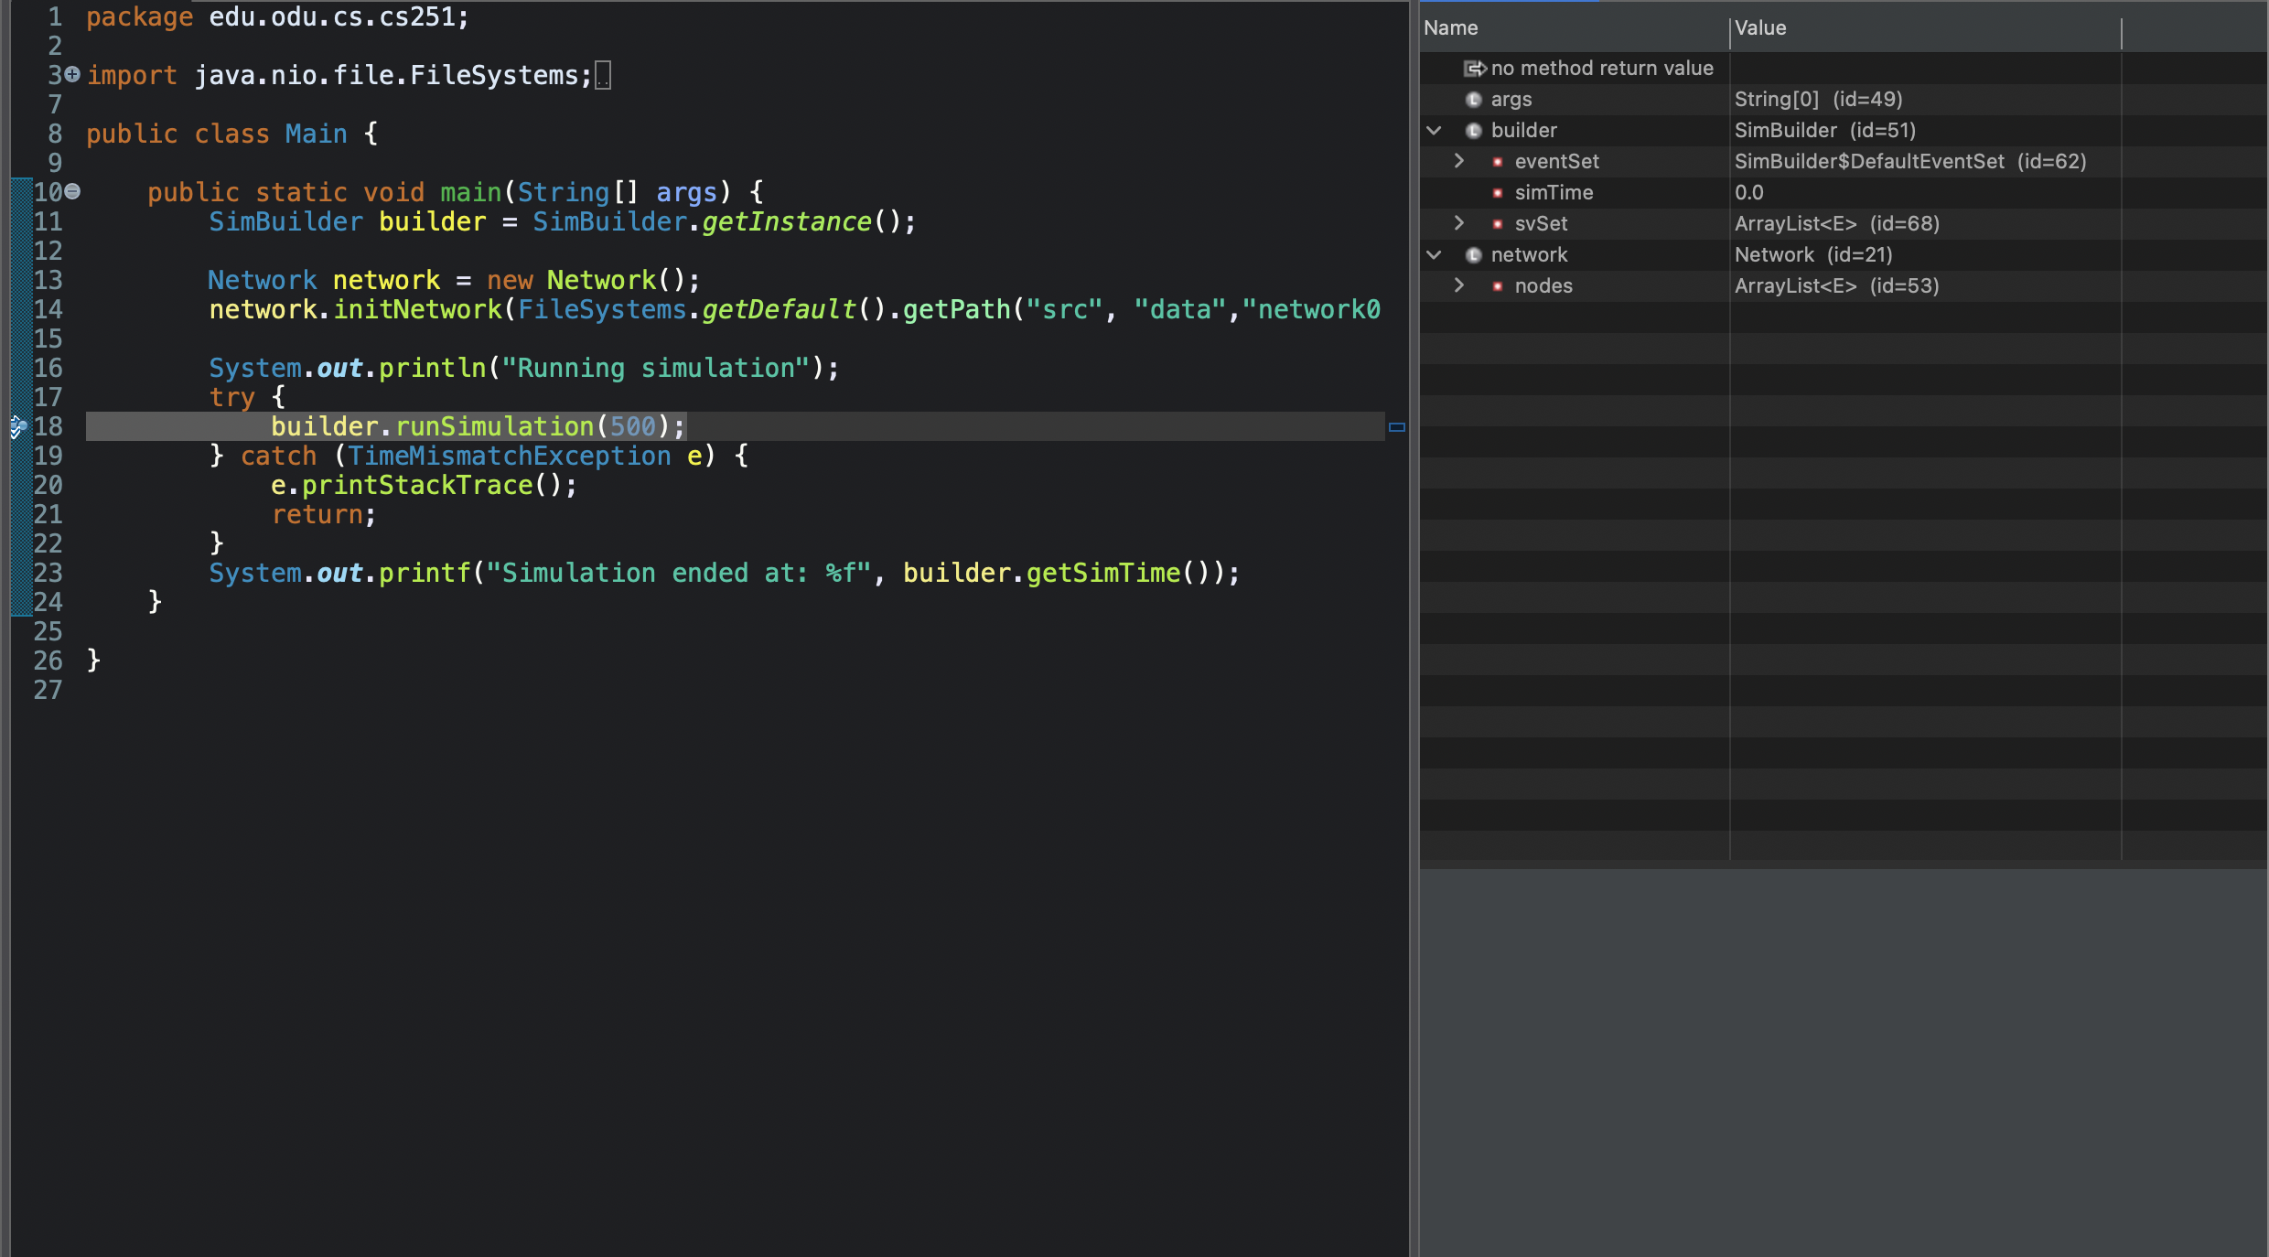

# Network.java Breakpoint Debugger Info

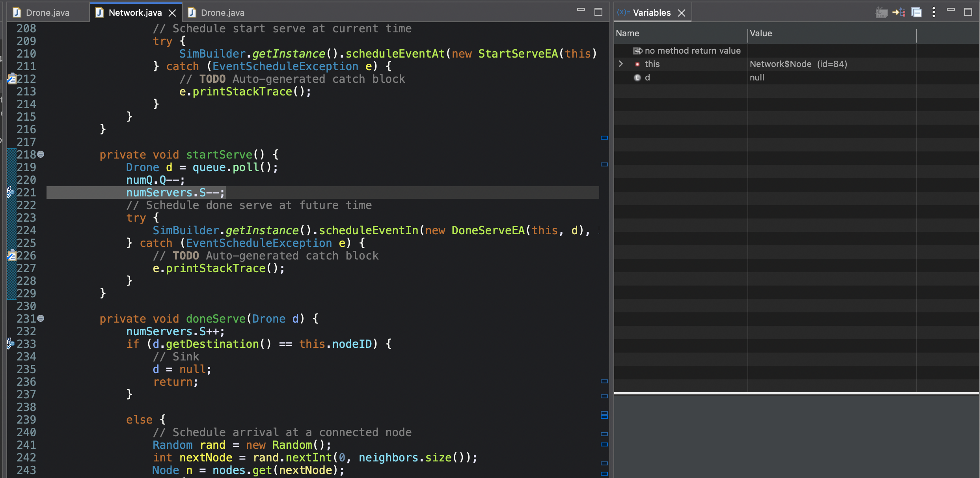

# Fixing Issue

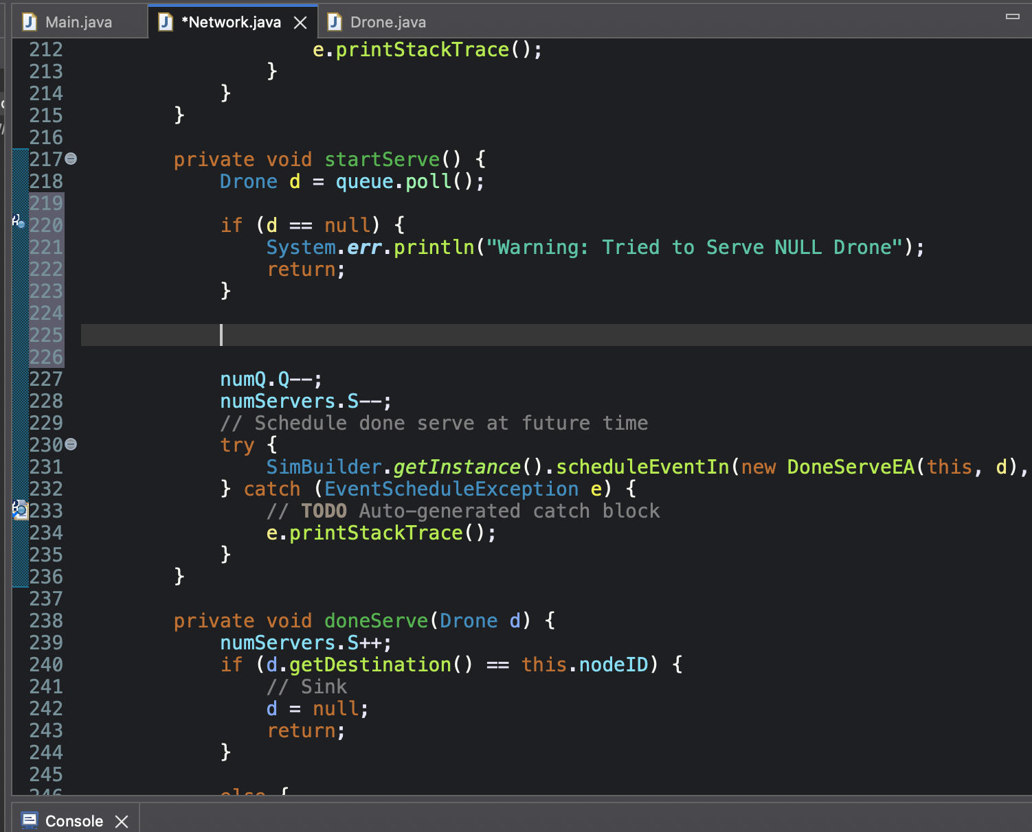

# New Run

Issue has been resolved.

 